2021-2022 School Crossing Posts
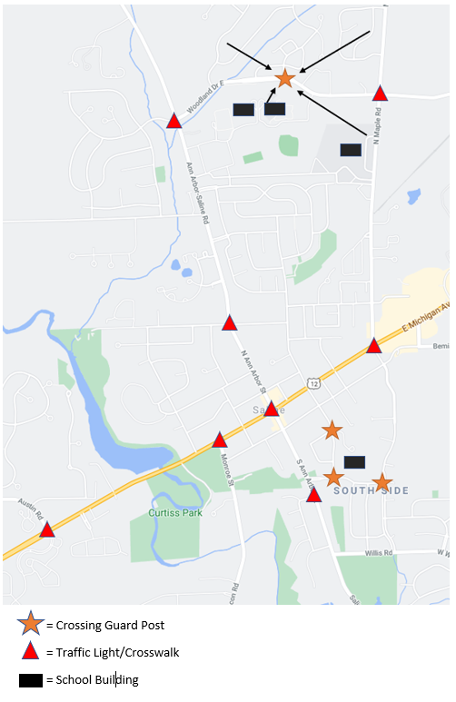

Planning Your Child’s Route to School
Federal and State guidelines have very specific recommendations for Crossing Guard locations. Crossing Guards are generally reserved for areas without traffic control devices (traffic lights with crosswalk) where large amounts of elementary aged children cross. Please take the time to plan a route with your child and practice walking that route together. Children are expected to learn pedestrian safety and be independent at crosswalks by Junior High age. Always cross at marked crosswalks and/or Crossing Guard locations. Your child may need to walk an extra distance to cross at a safer point. For instance, children living north of Woodland Drive can walk to a Crossing Guard point on Woodland at Sycamore Run if their parents do not want them to use other crosswalks.

Paid Crossing Guard positions are available, but labor is in short supply. If you are interested in being a Crossing Guard, please contact Sgt. Hartwig with the Saline Police department at ahartwig@cityofsaline.org.

